**GBM Hyperparameter Tuning**

Starting the tuning with default hyper parameters.

1. Shrinkage as 0.1

2. interaction.depth as 1

3. n.trees as 100 would not be suffice, hence putting n.trees as a large value, somewhere around 1500.

Computed the RMSE value, plotted Poisson deviance

YET TO DO

Next, we are increasing the interaction.depth as 3 (increase the depth of each tree from using a single split to 3 splits).

Observed that the loss function is minimised.

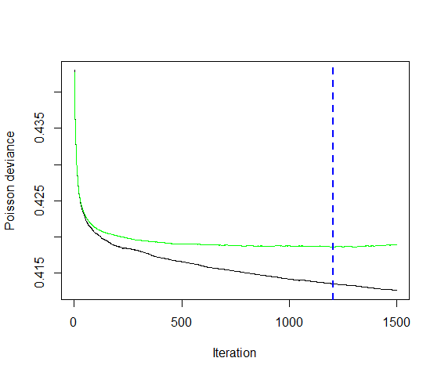

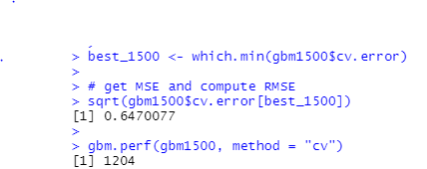

Tuning:

Now, with the observed values we can perform grid search.

First: Trying for learning rate: 0.1 and 0.3, and rest all values remains same.

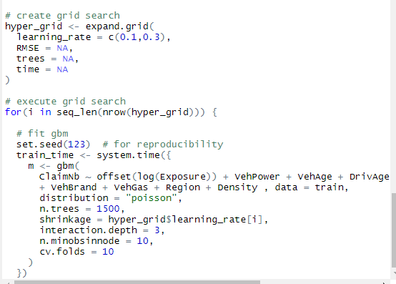

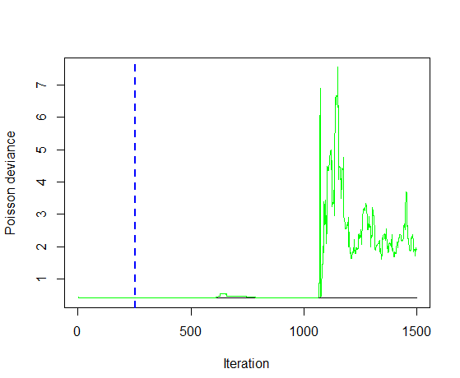

0.3:

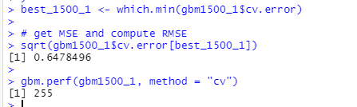

Results:

Next, we will set the learning rate at optimal level and tune the other parameters, interaction.depth and n.minobsinnode.

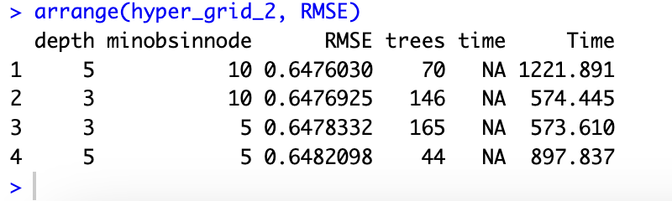

Took 10% subset of the data, and performed parameter tuning:

